**Traveling Waves and Phasor Homework (30 Points)**

(jas, Traveling Waves and Phasor HW.docx, 9/20/2025)

Use units and clearly label answers using 3 or 4 significant digits where appropriate. **Show your work** so that if necessary partial credit can be awarded.

1. Determine the wavelength in meters of a 2 GHz electromagnetic wave traveling through a vacuum, meaning up = c. (2 points.)

1. Determine the wavelength in miles of a 60 Hz electromagnetic wave traveling along a power line at a speed of 70% of the speed of light. (2 points.)

1. Two waves y1(t) and y2(t) have the same amplitude and frequency, but y2(t) leads y1(t) by 60°. Given y1(t) = cos[2π(1000)t], write the expression for y2(t) in terms of the cosine function using radians for the argument. (3 points.)

1. The voltage of an electromagnetic wave traveling on a lossy transmission line is given as follows where z is the distance in meters from the source:
2. Find the **frequency in Hz**, **wavelength in meters (m)** and **phase velocity of in meters per second (m/s)**. (2 points each for 6 points total for part a.)

1. Find given that the wave envelope equals 1.5 V for z = 2 meters. (2 points)

1. Find the phasor representations of the following time functions. Simplify your results to be of the form with r being a positive quantity and in radians. (15 points total.)
2. v(t) = 9cos(ωt – π/3) V. (2 points.)

1. v(t) = 12sin(ωt + π/4) V. (2 points.)

1. i(x, t) = sin(ωt – βx + π/6) A. (3 points.)

1. i(t) = cos(ωt + 3π/4) A. (4 points.)

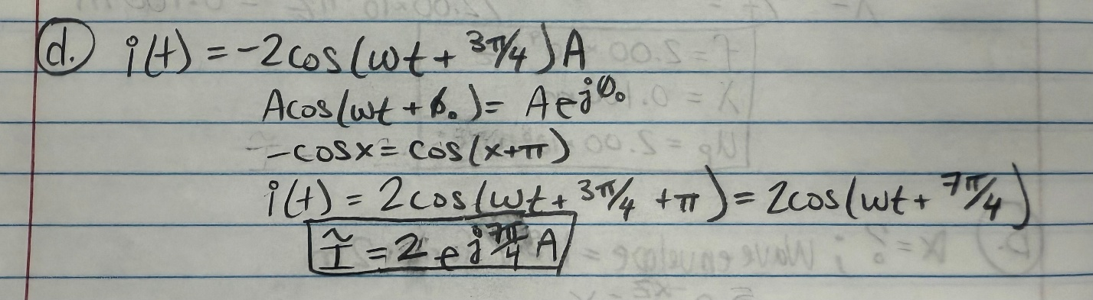

1. i(t) = 4sin(ωt + π/3) cos(ωt - π/6) A. (4 points.)

